**A Simple Code Generator**

**RA1911003010696**

**Sai Ram Pendyala**

**Aim:**

To implement a simple code generator.

**Program:**

#include<stdio.h>

#include<conio.h>

#include<string.h>

#include<ctype.h>

#include<graphics.h>

typedef struct

{

char var[10];

int alive;

}

regist;

regist preg[10];

void

substring (char exp[], int st, int end)

{

int i, j = 0;

char dup[10] = "";

for (i = st; i < end; i++)

dup[j++] = exp[i];

dup[j] = '0';

strcpy (exp, dup);

}

int

getregister (char var[])

{

int i;

for (i = 0; i < 10; i++)

{

if (preg[i].alive == 0)

{

strcpy (preg[i].var, var);

break;

}

}

return (i);

}

void

getvar (char exp[], char v[])

{

int i, j = 0;

char var[10] = "";

for (i = 0; exp[i] != '\0'; i++)

if (isalpha (exp[i]))

var[j++] = exp[i];

else

break;

strcpy (v, var);

}

void

main ()

{

char basic[10][10], var[10][10], fstr[10], op;

int i, j, k, reg, vc, flag = 0;

clrscr ();

printf ("\nEnter the Three Address Code:\n");

for (i = 0;; i++)

{

gets (basic[i]);

if (strcmp (basic[i], "exit") == 0)

break;

}

printf ("\nThe Equivalent Assembly Code is:\n");

for (j = 0; j < i; j++)

{

getvar (basic[j], var[vc++]);

strcpy (fstr, var[vc - 1]);

substring (basic[j], strlen (var[vc - 1]) + 1, strlen (basic[j]));

getvar (basic[j], var[vc++]);

reg = getregister (var[vc - 1]);

if (preg[reg].alive == 0)

{

printf ("\nMov R%d,%s", reg, var[vc - 1]);

preg[reg].alive = 1;

}

op = basic[j][strlen (var[vc - 1])];

substring (basic[j], strlen (var[vc - 1]) + 1, strlen (basic[j]));

getvar (basic[j], var[vc++]);

switch (op)

{

case '+':

printf ("\nAdd");

break;

case '-':

printf ("\nSub");

break;

case '*':

printf ("\nMul");

break;

case '/':

printf ("\nDiv");

break;

}

flag = 1;

for (k = 0; k <= reg; k++)

{

if (strcmp (preg[k].var, var[vc - 1]) == 0)

{

printf ("R%d, R%d", k, reg);

preg[k].alive = 0;

flag = 0;

break;

}

}

if (flag)

{

printf (" %s,R%d", var[vc - 1], reg);

printf ("\nMov %s,R%d", fstr, reg);

}

strcpy (preg[reg].var, var[vc - 3]);

getch ();

}

}

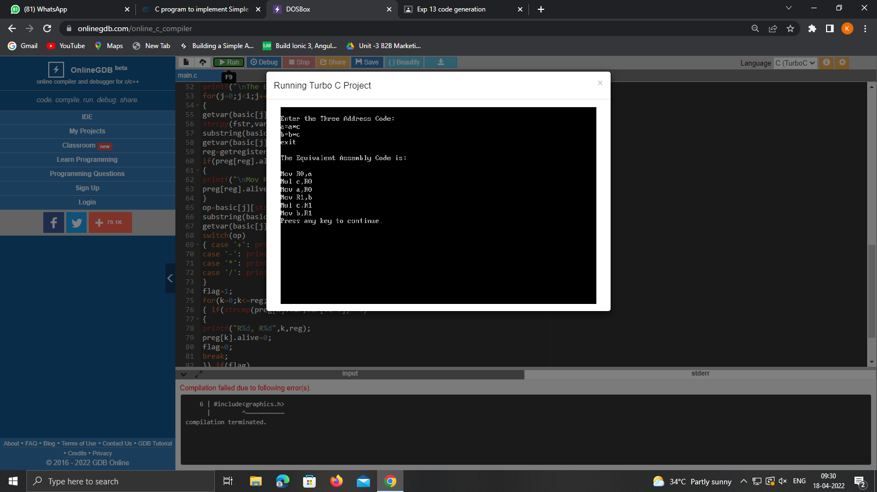

**Result:**

A simple code generator is successfully implemented.